LAB#6
Deadlockinconcurrency

OBJECTIVE:Implementing multiplethreadblockedresources with help of lock and deadlock conditions.
TASK:Createthreethreadsbyimplementingthreadsynchronizationblockthrough3locks.(Hint:Applyun-sequencedlockto analyze deadlock and solve it through provided solution.

CODEFORDEADLOCK:
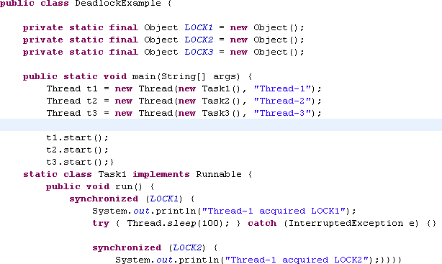
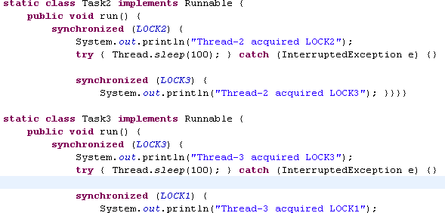

OUTPUT:
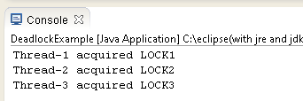

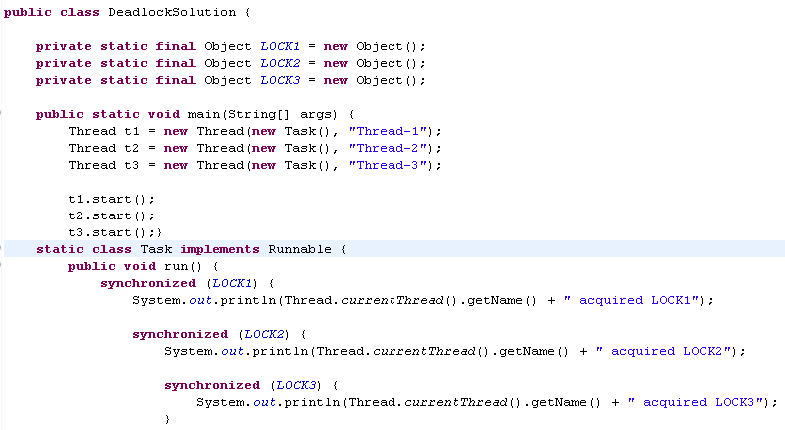
CODEFORDEADLOCKSOLUTION:

OUTPUT:
